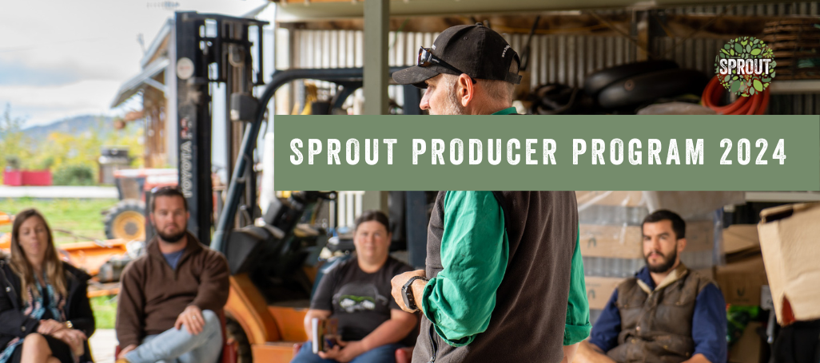

The Sprout Producer Program is a one-year scholarship designed to support and develop Tasmanian small-scale farmers and producers.

The program is for any small producer, growing food to sell fresh or value-add, or farming stock of any kind, and they can be at any stage in their journey. Producers should be focusing, or moving towards, supporting the local food communities in Tasmania with their business models and proposed channels to market.

The program's practical benefits include:
- Six field days
- Access to the Sprout Hub, our online education and resource platform containing Core Farming and Core Business courses.
- Monthly online group mentoring sessions
Participation of the field days, group sessions and completion of the educational units are required to graduate from the program.

Other benefits of the program include:
- Access to a network of knowledgeable mentors with diverse skills
- Access to customers and sponsors
- Opportunity to learn about soil health, business planning, marketing and more
- Becoming a part of a community of producers who provide support and friendship
- Opportunity for media coverage

Throughout the scholarship recipients gain access to mentoring, networking, education, and support with an in-kind value of over $8,000. There is a co-contribution portion for all successful applicants of $320, which assists Sprout to fund the costs of each individual participant's farm field day, and each year we can offer sponsored scholarships with additional benefits. These sponsored opportunities will be discussed with the applicants that make it through to the interview stage.

Selection Criteria
Applicants will be assessed based on their completed application form and responses to the questions addressing their farming background, their strengths and gaps on farm and their thoughts and plans. There is no specific requirement of skills, experience, duration of farm life, but more a genuine desire and need to learn, develop, improve, and receive mentoring to grow.
Applications progressing to stage two (those who have completed a successful application and met the criteria for the program) will be interviewed by the Sprout Board, General Manager and Producer Liaison to determine successful producers to join the program in 2024.

How to Apply
Application open date: Monday 14 August 2023 at 6:00am.
Application close date: Monday 25 September 2023 at 11:59pm.
Application Reviews: Tuesday 26 September to Friday 29 September 2023.

The Sprout Panel will conduct a review of applications and all applicants will be contacted by Friday 6 October 2023. Those successful in progressing to Stage 2 will be requested for an interview.
Interviews will be conducted Monday 16 – Friday 20 October 2023.
Successful scholarship recipients will be contacted on or around Monday 23 October 2023, and will be invited to attend the Growing Good Conference Dinner for the announcement and introduction to the Sprout Community.
If you have questions about this form or anything else to do with the application process or the program, please call Ollie Benson on 0478 616 254, or email ollie@sprout.org.au

Tell us about you...
This first short answer section is to introduce yourself. We want to know about you and your farm.
These questions do not form part of the assessable selection criteria.
General Details

Company/Farm name
ABN
Your Name
Farm address
Phone
Email
Website
Facebook: (if applicable)
Twitter: (if applicable)
Instagram: (if applicable)
Other Applicants name:
(if applying as a farming duo, etc)

Property Information

Property size
Active farming area
Type of farm (eg. beef, vegetables, sheep for milk, agri-tourism)
How long have you been farming?
Do you have organic certification or plans to convert in the future?

Relationship with Sprout Tasmania
Are you a Sprout member?
Have you ever attended any Sprout events?
How did you hear about Sprout and/or the SPP?
Have you ever applied for the SPP before? If yes, what year?

* We will add your details to our database as part of this application process. This is to ensure we can contact you about programs, events, workshops or other opportunities relevant to your farm. It also gives us an opportunity to put you in touch with others who may be in the same industry as you for the sharing of ideas and support.

Selection Criteria
The selection criteria questions are designed to give us an insight into who you are as a farmer, where you see your farm now and in the future and how the scholarship would be beneficial for your development.
Please provide detailed responses in the answer boxes below, so we can learn as much as we can about you.
You may also send other relevant documents when you email your application.
Note that you can keep typing in the answer box and it will continue to expand and simply push the remaining questions further down the page/s.

- Why do you want to be part of the Sprout Producers Program?

(type answer here)

- Can you explain what stage of farming/producing you are at?
If you are doing so, what are you currently growing or producing?

(type answer here)

Selection Criteria continued

- What are your goals for the future?

(type answer here)

- What are the main challenges you currently face on your farm or in your business?

(type answer here)

Selection Criteria continued

- If your application is successful, what outcomes would you like to see in your business during the program?

(type answer here)

- With Sprout’s ethics and principals in mind, how is your business going to contribute to the local Tasmanian food system?

(type answer here)

Terms & Conditions

- Applications are open to any Tasmanian small producer, growing food to sell fresh or value-add, or farming stock of any kind, and they can be at any stage in their journey.

- Applicants should be able to demonstrate that their farming and business priorities are to support the local food communities in Tasmania through their business models and proposed channels to market.

- Successful scholarship recipients are required to become members of Sprout Tasmania.

- By submitting this application, you acknowledge that, if successful in gaining a position in the program for 2022 you will receive a Sprout Producer Program Scholarship with access to services and support valued at over $4,000.

- In addition, as part of gaining a successful scholarship position you agree to pay a co-contribution to the program of $285, payable to Sprout Tasmania at the commencement of the program.

- Successful applicants will be invited to attend Sprout’s annual conference, Cross Pollinate. We request that applicants consider attending this conference, as the successful program participants for the 2022 year will be announced and introduced to the Sprout Community during the event.

- The time commitment required from each successful applicant during the 12 months of the program involves completion of seven education assignments at set times throughout the year, as well as being present at each farm field day of each producer in the cohort in various locations around the state.

I, ________________________________________, of ____________________________________,
Full Name of Applicant/s Farm Name

declare that I have completed this application form and provided to the best of my knowledge a true and accurate reflection of my current situation and future needs for my business and farm. I also agree to the conditions of application as stated on this form.

______________________________________________ on ________________________________.
Signature/s Date

Please complete this form and return it to Ollie Benson via email - ollie@sprout.org.au
If you have any other relevant documentation feel free to include it with your application.
Applications close Monday 26 September, 2022, 11:59pm.
Applications received after this date will not be considered.

